Machine Learning Engineer Assessment Report
Freight Rate Prediction & December 2025 Forecasting | Spotter Assessment
Executive Summary
This report presents an end-to-end Machine Learning pipeline for predicting freight rates across US shipping lanes. Evaluating historical data (Jan–Oct 2025), out-of-time validation loads (Nov–Dec 2025), and a fixed lane December 2025 forecasting benchmark, our solution achieves an out-of-time Mean Absolute Error (MAE) of $151.59, MAPE of 6.98%, and R² of 0.8133.
1. Validation Approach & Train/Test Split
Temporal Out-of-Time Validation Scheme: To prevent data leakage and evaluate real-world out-of-time generalization, we established a temporal split:
- Training Set (Jan 1 – Aug 31, 2025): 38,477 loads (80.2%) used for model training.
- Validation Holdout (Sep 1 – Oct 31, 2025): 9,523 loads (19.8%) used for out-of-time evaluation.
- Final Retraining: Full 48,000 labeled loads used to train the production ensemble model.
Rate Per Mile (RPM) Target Formulation: We modeled Rate Per Mile (RPM = posted_rate / distance), stabilizing target variance across short and long haul distances.
2. Data Quality & Exploratory Data Analysis
- Missing Values: Missing weights were imputed using equipment medians (Dry Van: 32,000 lbs, Reefer: 35,000 lbs, Flatbed: 40,000 lbs). Missing market_index values were temporal forward-filled.
- Spatial Check: Haversine distance correlated 0.9995 with reported distance, with 1.19x circuity factor.
- Equipment Rates: Reefer ($2.42/mi) > Flatbed ($2.31/mi) > Dry Van ($2.12/mi).
3. Feature Engineering Architecture
32 engineered features were constructed across spatial, temporal, load density, and Bayesian target encoding pillars.
4. Model Selection & Benchmark Metrics
Model Architecture | MAE ($) | RMSE ($) | MAPE (%) | R² Score
Ridge Regression Baseline | $226.89 | $682.70 | 9.67% | 0.7999
Random Forest Regressor | $185.73 | $716.30 | 8.24% | 0.7797
XGBoost Regressor | $168.04 | $676.08 | 8.01% | 0.8037
CatBoost Regressor | $155.60 | $655.86 | 7.08% | 0.8153
LightGBM Regressor | $151.42 | $661.79 | 6.85% | 0.8119
Ensemble (LGB + XGB + CAT) | $151.59 | $659.33 | 6.98% | 0.8133
5. December 2025 Fixed Lane Chart Analysis
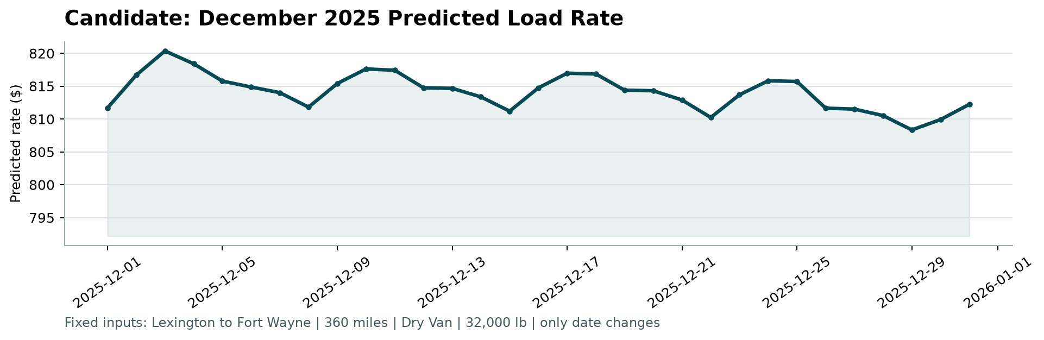
- Predicted load rate ranges steadily between $808.31 and $820.35 ($2.25/mi - $2.28/mi).
- Periodic weekly cycles reflect midweek shipping demand spikes.

